Lesson Plan 9
Lesson 9: Creating NPCs, Customizing Appearance. Dialogue Creation (2 hours)
Welcome to the ninth lesson of our Roblox course!
In this lesson, we will focus on how to create your own NPC (non-player characters), customize their appearance, and implement a dialogue system. You will learn how to turn ordinary models into full-fledged characters with their own stories and characteristics.
Next, we will add depth to the interaction with NPCs by learning to create dialogues that not only inform the player but can also affect the course of the game. This will help you create interactive content in games.
So, get ready to bring your NPCs to life and create exciting dialogues that will make your Roblox world unforgettable!

1. Introduction and Homework Review (10 minutes)
Greetings, attendance check, and discussion of the homework. Give an opportunity for volunteers to present their projects.
2. Creating NPC, Customizing Appearance (45 minutes)

2.1 Creating an NPC
To add an NPC, we need to go to the Avatar section and select the Rig Builder menu item.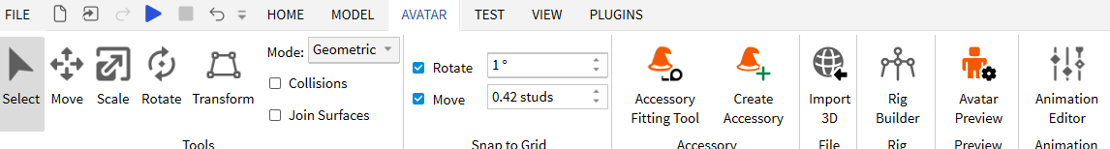

Let's take a closer look at the dropdown menu items of this tool.
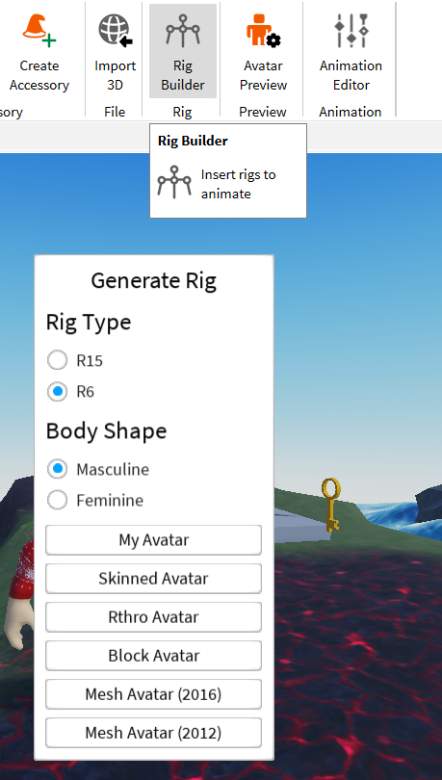
- Rig Type:
  - R15: Selecting this option will create a character rig consisting of 15 body parts. This allows for more complex and realistic animations compared to the older R6 model.
  - R6: This is an older rigging system in Roblox, consisting of 6 body parts. R6 animations are simpler and less flexible, but they may be preferred for certain game styles.
- Body Shape:
  - Masculine: Choosing this option will create an NPC with more masculine body features.
  - Feminine: Choosing this option will create an NPC with more feminine body features.
- My Avatar: This button allows you to use your current avatar as a base for creating an NPC.
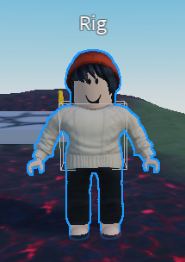
- Skinned Avatar: Creates another type of NPC.
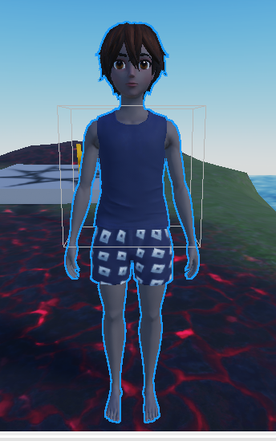

- Rthro Avatar: Rthro avatars are more realistic models that provide unique proportions and appearance. Selecting this option allows you to create an NPC based on Rthro.
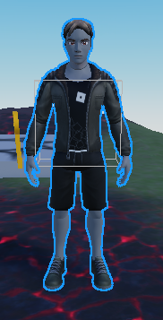
- Block Avatar: Creates a character with the classic "blocky" Roblox appearance, characterized by angular shapes and a less detailed body.
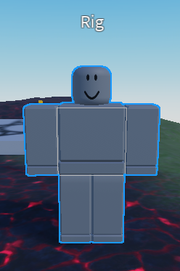
- Mesh Avatar (2016): Choosing this option allows you to create an NPC using a mesh model that was popular in 2016, with corresponding characteristics and style.
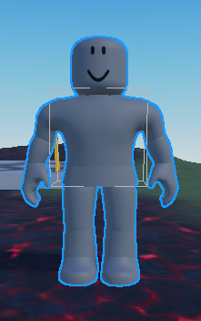
- Mesh Avatar (2012): Similar to the previous item, this will create an NPC using a mesh model that was current in 2012, offering an older appearance and style of the character.
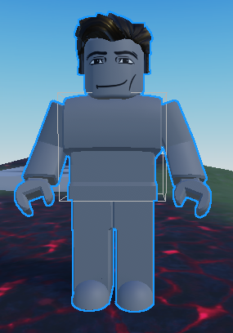

For our work, I suggest selecting "Mesh Avatar (2016)" as an option that is more familiar and closer to the appearance of our characters.

2.2 Customizing Appearance
Our NPCs by default have a gray skin color. Let's change that. For this, we need to find the Rig model that we added to the Workspace, expand its contents, and select "Body Colors".
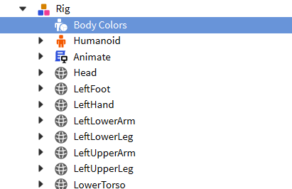
In the "Properties" window of this object, we have the ability to change the color of the various parts of the character's body. Each body part can be colored in one of two ways, using different parameters.
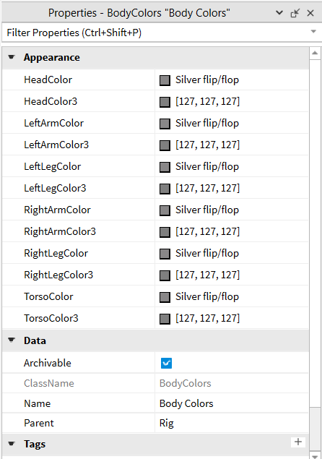
For the head (Head), for example, we can use the standard color palette by selecting the desired color in the HeadColor parameter.
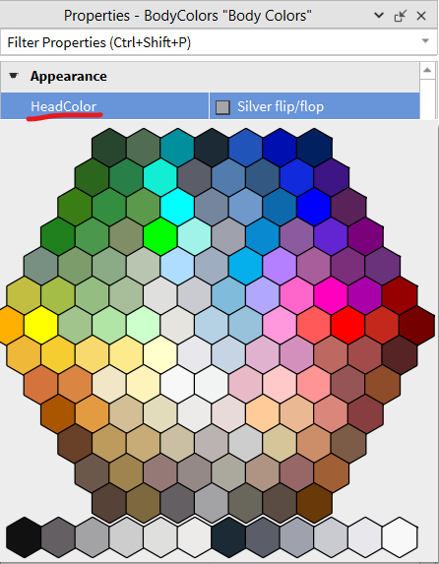
Alternatively, we can set the color using a gradient by clicking on the color square in the HeadColor3 parameter.

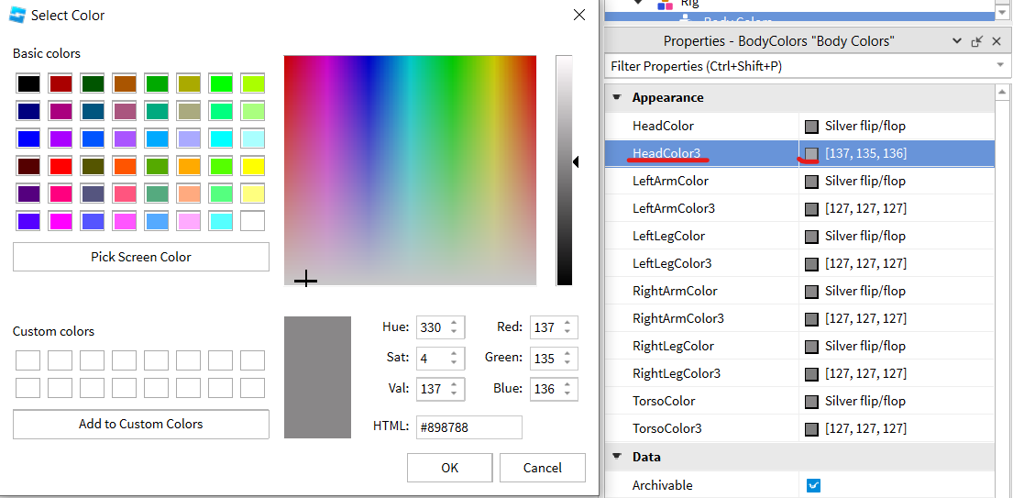
Let's color all the parts of our character's body.
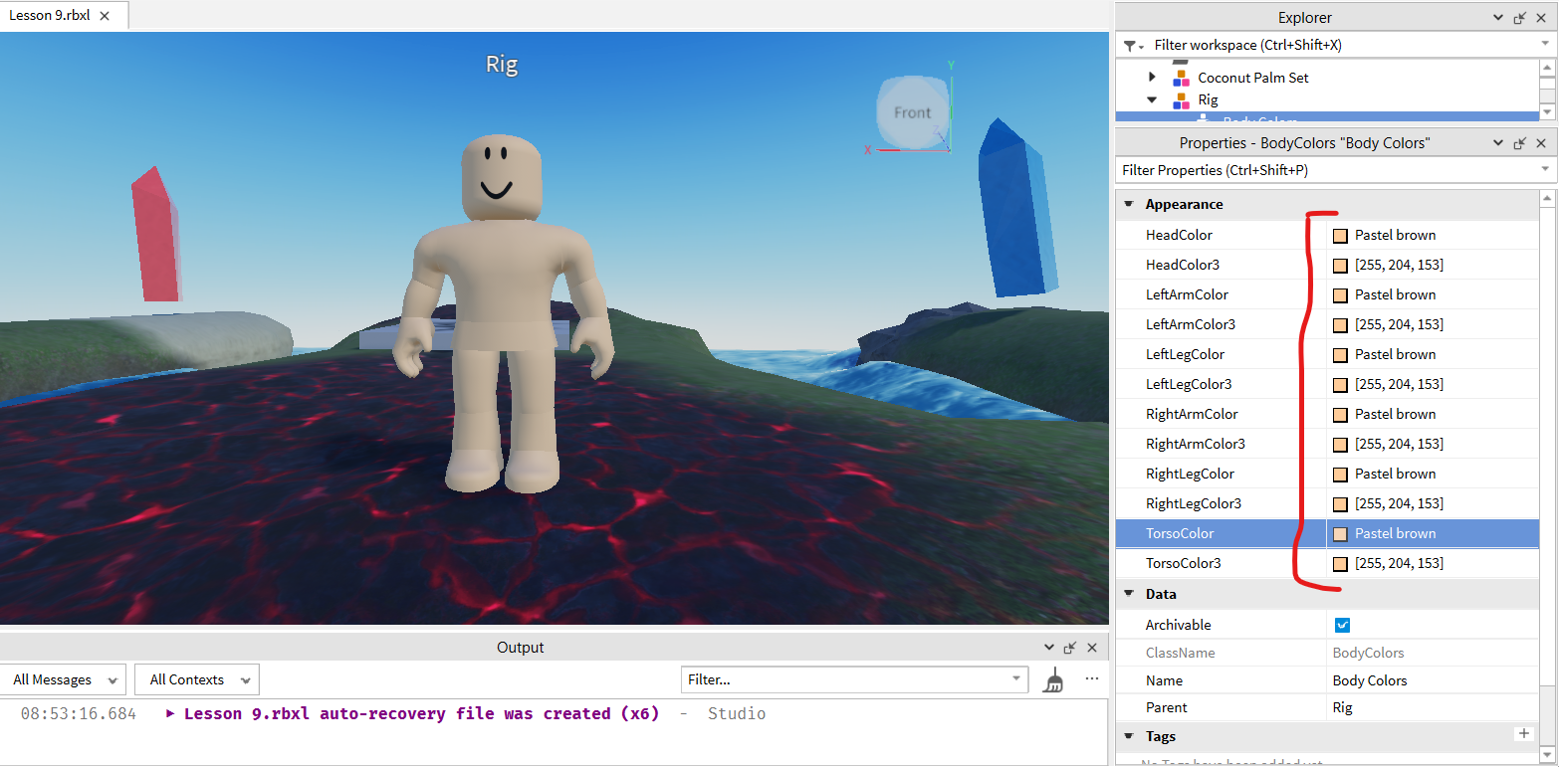

2.3 Clothing Customization
There are several methods to customize clothing for our NPC. Now let's look at one of the ways using the Toolbox. Unfortunately, there is no separate category for clothing in the Toolbox, so we will need to use the search bar to find the necessary items. Here are a few examples of queries you can use:
t-shirt — to search for t-shirts,
jacket — to search for jackets,
hair — to choose hairstyles,
pants — to find pants,
dress — to find dresses,
shorts — to search for shorts,
hat — for hats,
cap — for caps,
shoes — for shoes,
boots — for boots,
glasses — for glasses,
gloves — for gloves,
scarf — for scarves,
belt — for belts,
tie — for ties,
watch — for watches.
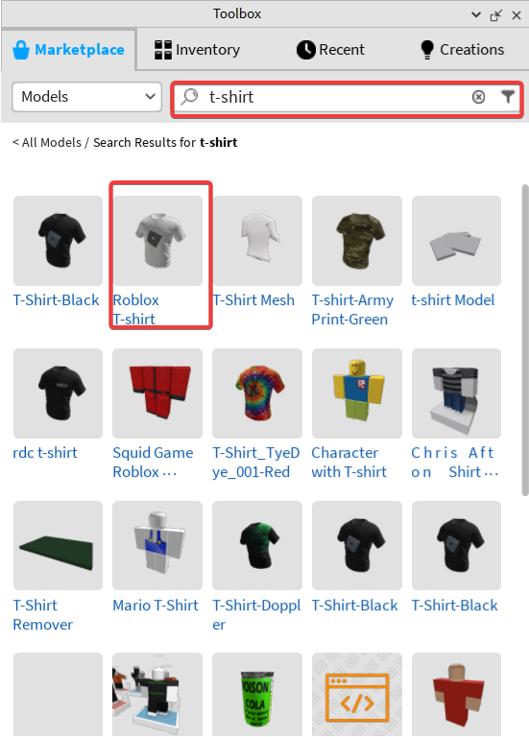
Next, having selected an item we like, we drag it into our three-dimensional space. At this moment, it is important to pay attention to the type of object — if it is marked with an accessory icon, such as a wizard's hat, then all is well and we can continue. If there is no icon, such an object may not be suitable, as it will not be displayed correctly on the character model, and it would be better to choose another.
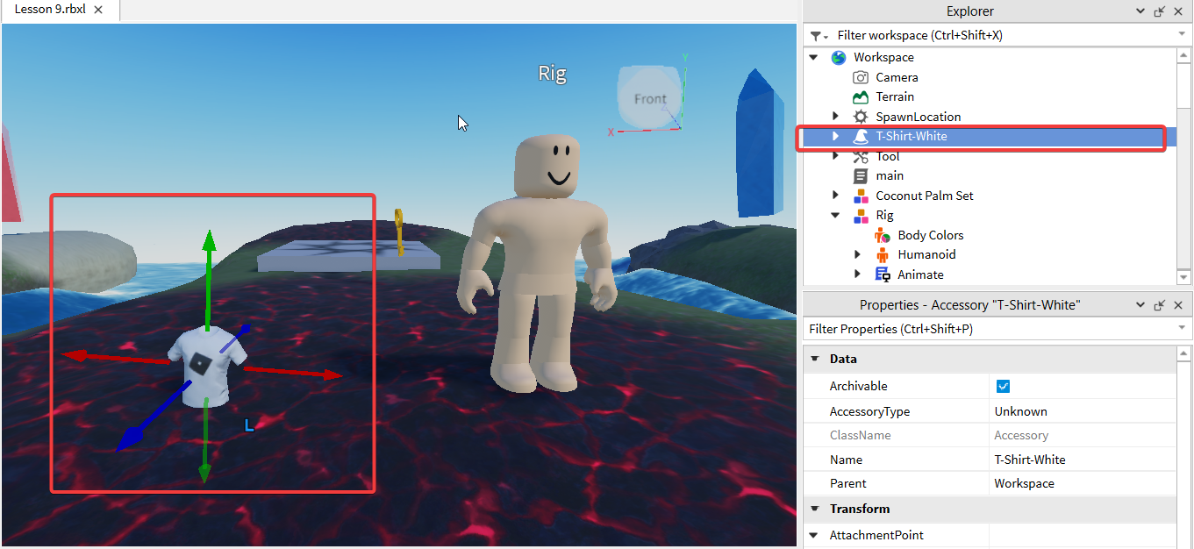
After that, we find the added object in the Workspace and drag it with the mouse into the container with our NPC. If the object is suitable, it will be applied automatically, and the selected clothing will appear on the NPC model.
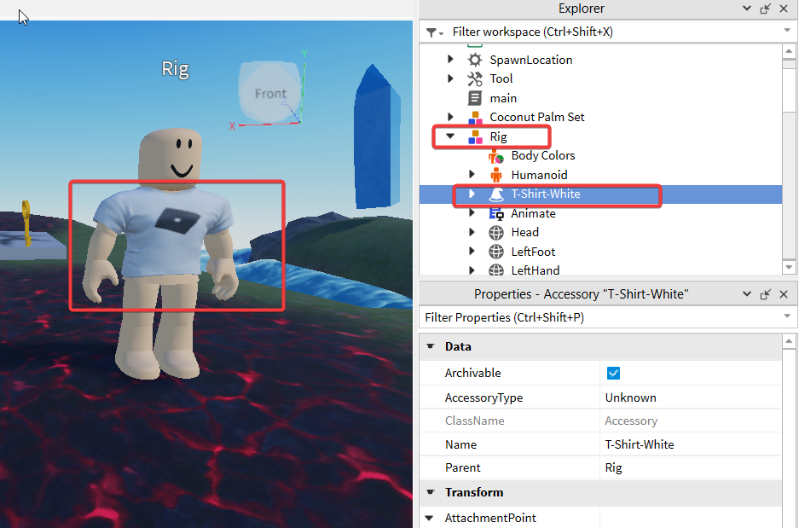
Encourage the children to take the time to customize the appearance of their NPC, to make it unique and memorable.
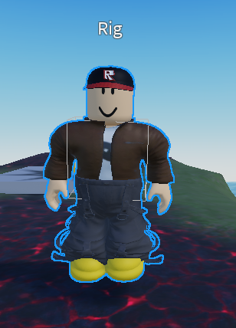

3. Break (10 minutes)

4. Creating Dialogue (45 minutes)

4.1 Adding Dialogue
To add dialogue, we first need to locate the head of our NPC. Once the head is selected, we use the plus button to add a Dialog object.
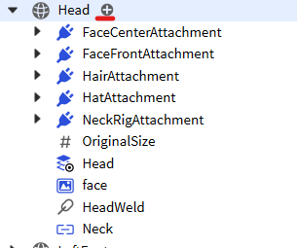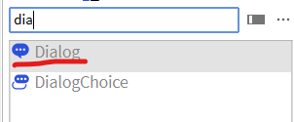
This Dialog object will serve as the starting point for our dialogue.

4.2 Dialogue Settings
Let's take a detailed look at the properties of this Dialog object.
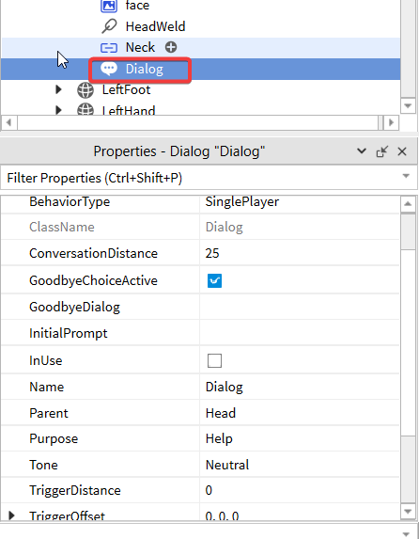
- ConversationDistance: The distance at which a player can interact with the dialogue, in this case, the value is set to 25.
- GoodbyeChoiceActive: An option that indicates whether the choice to end the dialogue (the opportunity for the player to conclude the conversation) is active.
- GoodbyeDialog: The text for the goodbye option to end the dialogue.
- InitialPrompt: The initial message or question presented to the player at the beginning of the dialogue. Important! This field must be set; otherwise, the dialogue will not display.
- Purpose: The purpose of the dialogue, which has three values, and the value determines the symbol that will be displayed over the NPC's head. Help - ?, Quest - !, Shop - $.
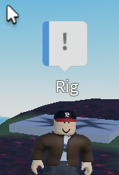
- Tone: The tone of the dialogue affects the color of the dialogue stripe. Neutral – blue, Friendly – green, Enemy – red.

4.3 Adding Response Options
If we set these values to the corresponding properties,

Then upon clicking, the NPC will simply say "Hello!". We need to add more response options.
To add dialogue options, we need to press the plus button on the Dialog object and select "DialogChoice".
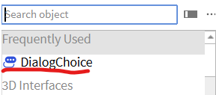
The "DialogChoice" object has two key properties:

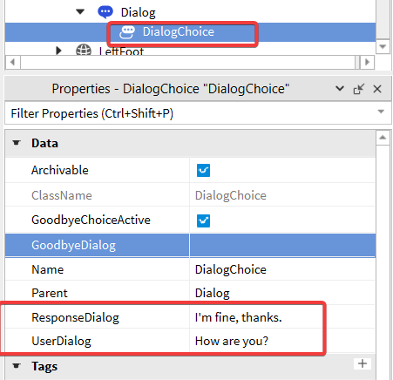
- ResponseDialog": what the NPC will respond with to the player's chosen line.
- "UserDialog": the line that the player can select in the dialogue.
We will add three such objects to provide three different dialogue options.
Now let's add three dialogue options with corresponding NPC responses, one for each "DialogChoice" we created:

"How are you?" — The NPC will reply: "I'm fine, thanks."
"Who are you?" — The NPC will reply: "I'm wizard, Harry!"
"What is your name?" — The NPC will reply: "My name is Bob."
In the workspace, our dialogue will look like this:
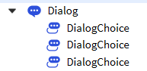
And if you start the game, it will be like this:
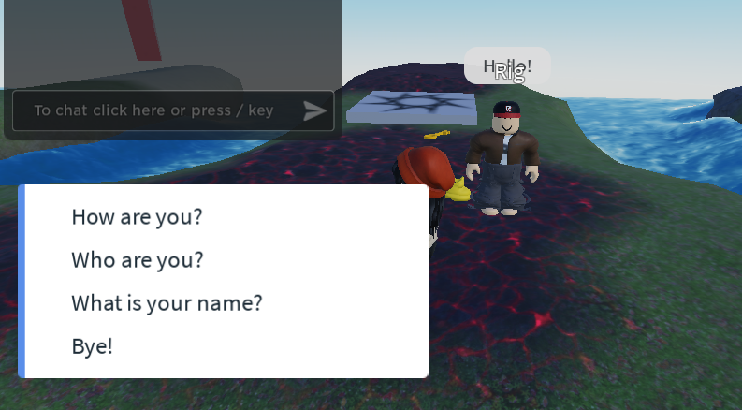
We see the NPC's greeting, 3 options for our line, and an item for saying goodbye and ending the dialogue.
During testing, we may find that after selecting any of the proposed dialogue options, the dialogue ends. To explore other branches of the dialogue, it is necessary to start the conversation with the NPC from the beginning.
This allows us to visualize the dialogue system as a tree structure or graph, where branches with possible dialogue options stem from the starting phrase, which acts as the root. Moreover, we can add "DialogChoice" to another "DialogChoice", thus creating a complex structure with a multitude of potential questions and answers..
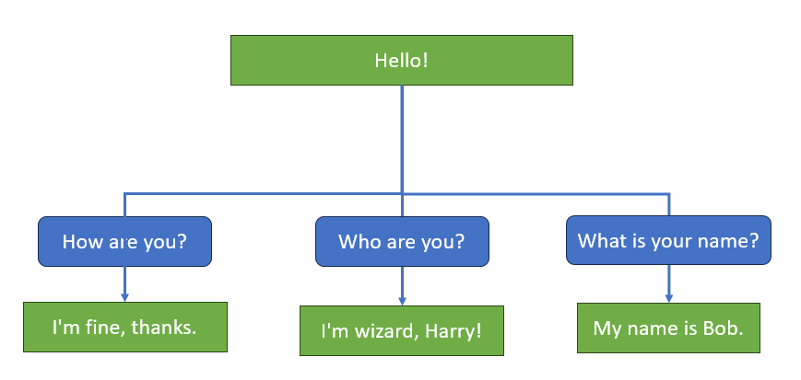
The main feature here is that we can follow this dialogue tree from top to bottom only once. To try another path, we will need to start interacting with the dialogue anew.
You can find the diagrams in the lesson content folder.

4.4 Tree Structure of Dialogue
Now let's build such a branched dialogue structure and then reproduce it in Roblox.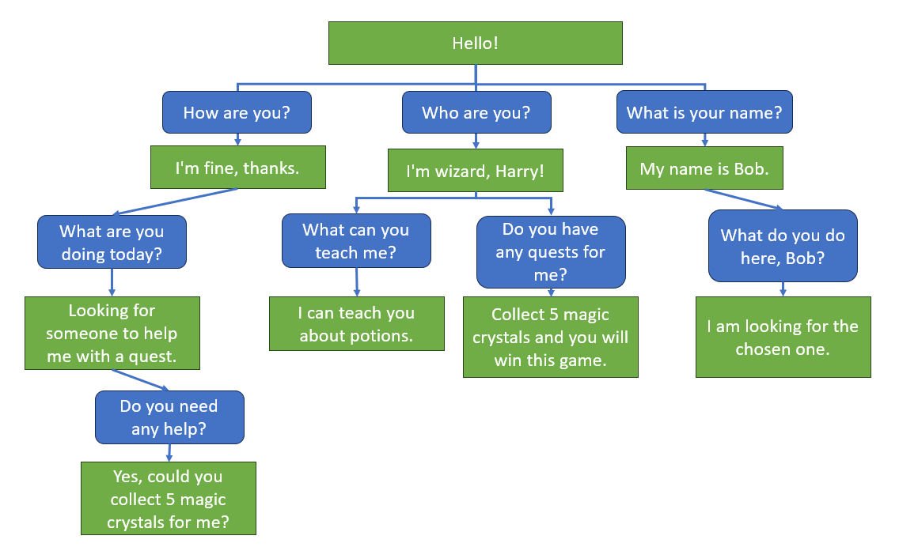
For this, we will need such a structure.
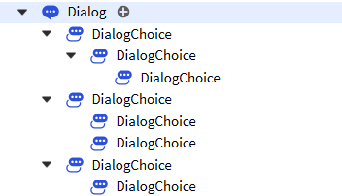

5. Homework (5 minutes)
Your homework will consist of the following:
Create a new non-player character (NPC) in your Roblox Studio world. Choose a unique appearance for it, select clothes and accessories to make it stand out among other characters.
Add an NPC dialogue with three different riddles. Each riddle should offer the player four answer options.
Program the dialogue so that choosing the correct answer allows the player to move on to the next riddle. If the answer is wrong, the NPC should say: "Wrong answer. You have lost."
If the player guesses all three riddles correctly, they should receive the message: "All answers are correct. You have won!"
Think about interesting and creative riddles that will be fun and at the same time provoke players to think. Ensure that the logic of your dialogue works correctly and that all possible developments of events are provided for depending on the player's choice. Good luck!

6. Feedback (5 minutes)
At the end of the lesson and upon completing independent tasks, it's important to gather feedback from the students. This helps to understand not only what was most useful and interesting for them but also to identify areas that may need improvement or further explanation.
Idea for conducting a feedback session:
Positive Point: Ask the children to take turns sharing what they liked most during the lesson. This could be a specific tool, effect, or just the general teaching approach.
Area for Improvement: Also, invite students to express what they did not like or what they think needs to be improved. This could be the complexity of the material, pace of teaching, or some technical aspects.
Summary: After everyone has spoken, draw conclusions. Note the general trends in the feedback and discuss what changes or improvements could be introduced in future lessons.
The feedback session is a valuable tool for the teacher, as it provides specific information about how the lesson was perceived by the students. This can also be a motivating factor for the children, as they see that their opinions are taken into account.

